**About Me:**

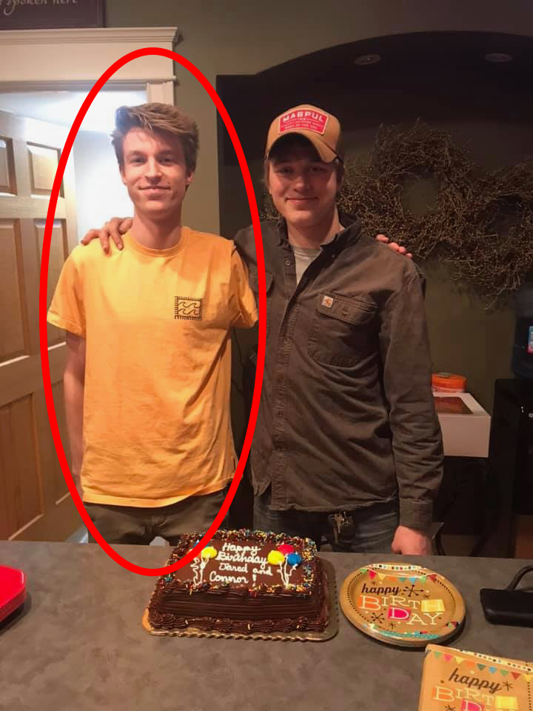Hello there, my name is Jared Heeringa (He/Him/His).

I am currently studying Computer Science here at Aurora University. This is my first year at Aurora, but I’m a transfer student who has previously attended Waubonsee Community College and Grand Canyon University. At Waubonsee I primarily focused on completing my general education classes while GCU was going to be where I got my degree, but after a year I realized that their academic programs were not all that great and consisted of dated technologies.

I am currently enrolled in CSC4500 because it is one of the required classes for the Computer Science degree here at Aurora. I have a little bit of prior experience with creating and managing databases from my php class at GCU, but concepts like normalization were only very briefly covered. At the moment, I am not too sure of what I want my future career to be but I’m thinking it might involve some form of networking. This last year at GCU, I took an IT and networking class which I found really interesting and enjoyable. As for personal goals, I don’t really have any major ones at the moment except maybe getting a good/enjoyable job. At the moment, I’m not a part of any organizations or clubs at Aurora, but I think that I will look into it and see if there are nay that might interest me.

Figure : Me & My Cousin

**More About Me:**

I am from and currently still live in Batavia, Illinois. I’m not sure if I will stay in this state when I eventually move out, but after experiencing Arizona for a year I know I don’t want to be anywhere near that state during the summer months. I think I’d also like to live somewhere that still has seasons just maybe somewhere with little less frigid winter months.

As for family, I currently live with my mom and dad at home with my 2 brothers and dog. I am the oldest sibling in my family. The second oldest, my brother Jackson, just started college this year at Northern Iowa University and will be playing football for them.

Some of my hobbies include playing video games, chatting with friends, and messing around with technology. At the moment, the game that I’ve been playing the most of is Red Dead Redemption 2. I have finally (took me way too long) finished the main story and am on to the epilogue. Another game that I was addicted to for a while was the Half-Life series. After having heard great things about the games for so long, I finally picked up the whole series while it was on sale and it’s now one of my favorite story games I’ve played.